**PROJECT REPORT**

END-TERM REPORT

**CGPA CALCULATOR**

**Python Programming (INT213)**

Submitted By:

|  |  |  |  |  |
| --- | --- | --- | --- | --- |
| Sr. No. | Registration No | Name of Students | Section -group | Roll No. |
| 1 | 11903484 | Ayush Sharma | K19SJ-1 | 26 |
| 2 | 11915679 | Abhishek Rana | K19SJ-1 | 60 |
| 3 | 11902091 | Rohan Pandey | K19SJ-1 | 04 |

Submitted To**: Ms Chavi Kapoor**



**School Of Computer Science and Engineering**

**Lovely Professional University, Jalandhar, Punjab, India- 144411**

**ACKNOWLEDGEMENT**

We take this opportunity to present our votes of thanks to all those guideposts who acted as lightening pillars to enlighten our way throughout this project that has led to the satisfactory completion of this study.

We are really grateful to Chavi mam for providing us with an opportunity to undertake this project and providing us with all the facilities.

Lastly, I am thankful to all those, particularly the various friends , who have been instrumental in creating a proper, healthy and conducive environment and including new and fresh innovative ideas for us during the project, without their help, it would have been extremely difficult for us to prepare the project in a time-bound framework.

**Contents**

Acknowledgment……………………………………………………………………

1. Introduction and description of the Project………………………………. 4

2. Tkinte and Matplotlib..................................………………………….....3

3. Student roles and responsibilities.…………………………………………….9

4. Learning outcomes and Coclusion...............................................10

5. Bibliography……………………………………………………………………....……11

**INTRODUCTION**

Project- “CGPA Calculator”.

Cumulative Grade Point Average (CGPA) is an educational ranking/evaluation method. The CGPA is a figure that reflects the grade point average for all classes you have taken and for classes for which you have received credit by means such as testing at your school/College/University. School/College/university. Policies vary in the way they evaluate credit for courses transferred to your current school from another. To calculate your CGPA you need to know the total number of grade points you have earned and the total number of credit hours you have attempted. In mathematical terms, the CGPA score is a "weighted mean," wherein the influence each grade has on the cumulative score depends on the number of credit hours the course was worth. Additionally, courses audited or taken on a "Pass/Fail" basis are omitted from the CGPA calculations completely.

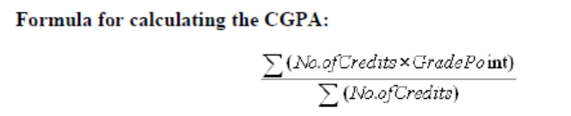**DESCRIPTION  
(with screenshots)**

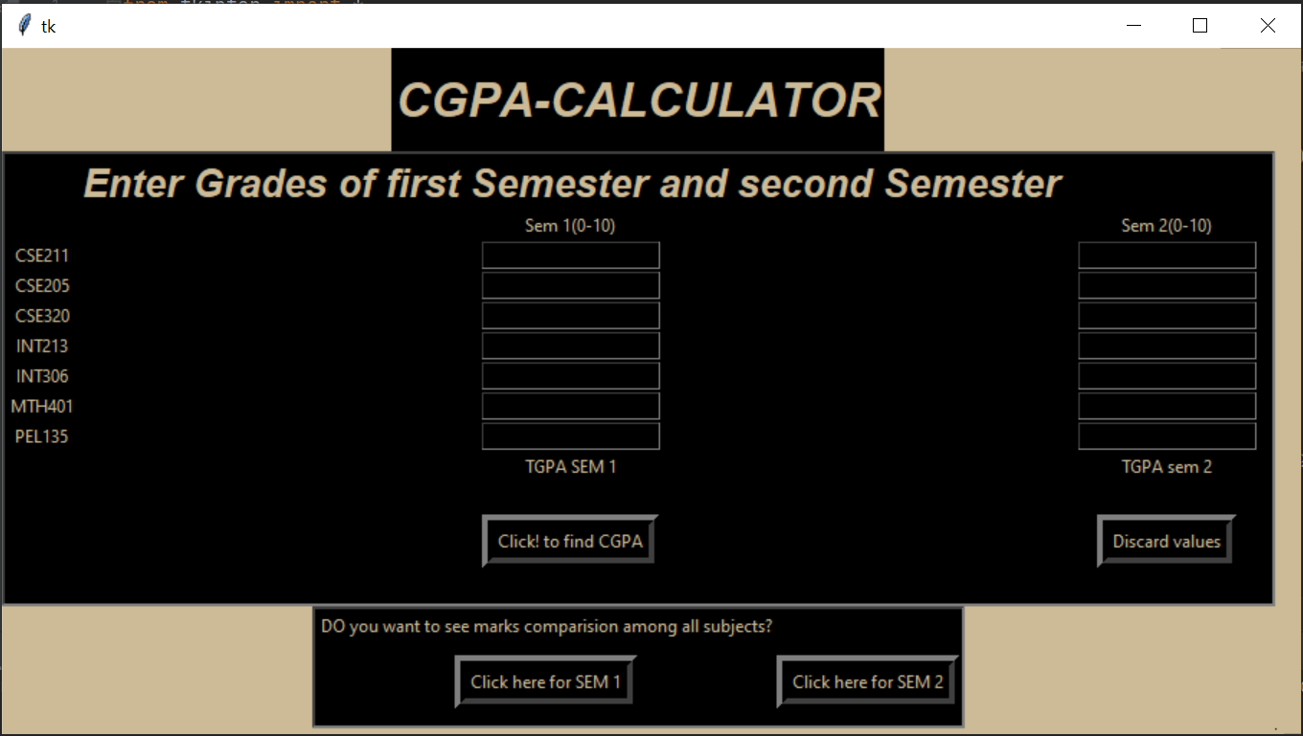

This interface opens after user runs the program. Window shows 7 subjects with input fields in front of them where user is supposed to enter inputs.

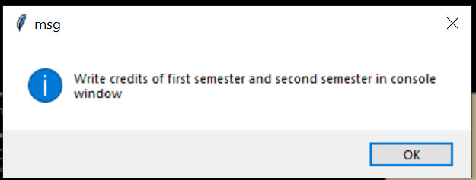

User enters their GPA of each subject in the input fields and press the “Calculate CGPA” button which prompts the message box

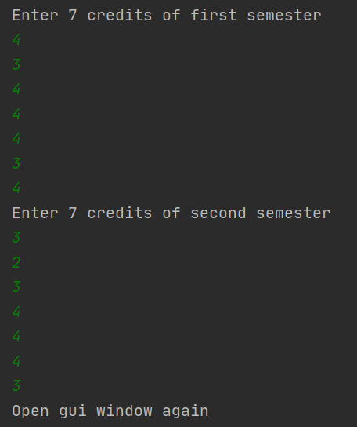

User enters credits in the console then again in the gui window a messagebox is shown...

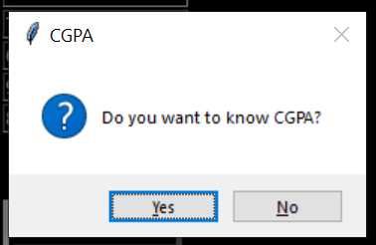

After pressing the yes button on the message box another message box opens showing the user’s grade.

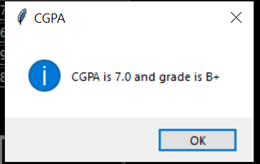

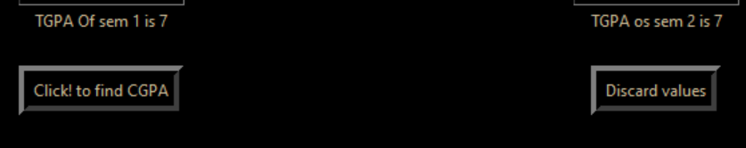Message box opens that shows the users cgpa as well as the total final grade and the tgpa is shown on the frame above buttons.

**Semester marks comparison**

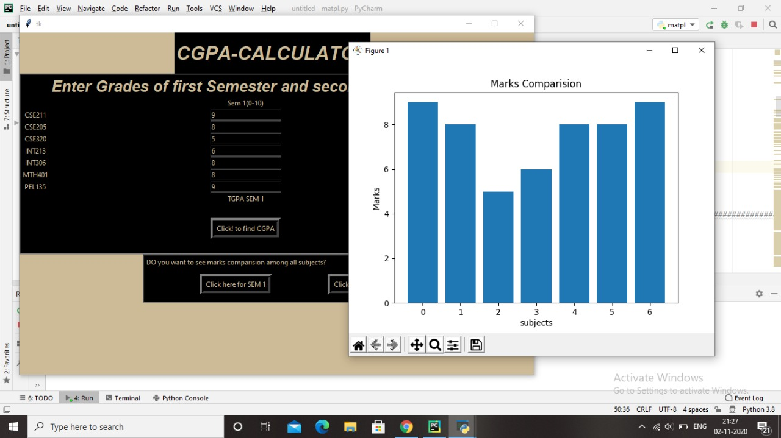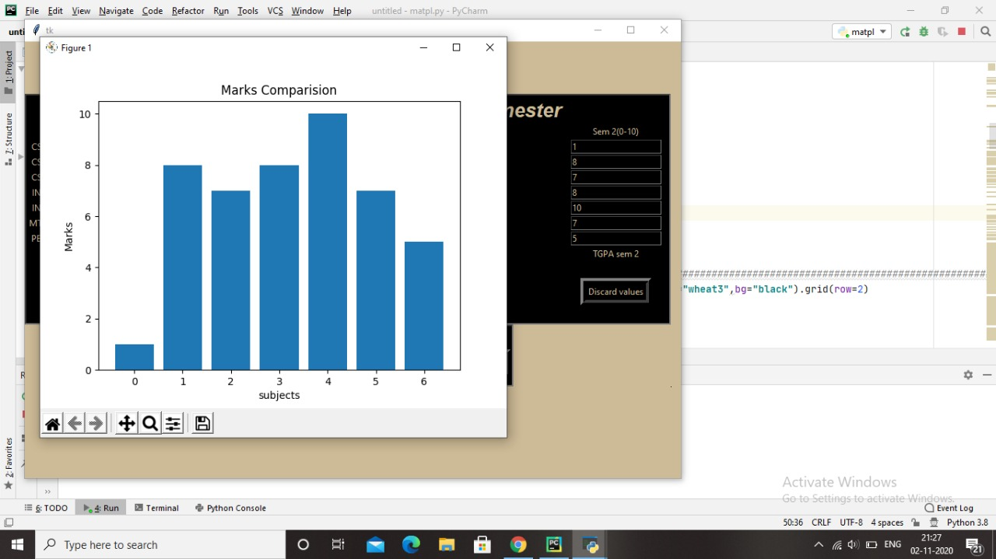

**Our grade point consideration**

|  |  |
| --- | --- |
| **Grade** | **Grade Point** |
| O | 10 |
| A+ | 9 |
| A | 8 |
| B+ | 7 |
| B | 6 |
| C+ | 5 |
| Reappear | 4 |
| Below “Fail” | |

**Module used- Tkinter**

Tkinter is the standard GUI library for Python. Python when combined with Tkinter provides a fast and easy way to create GUI applications. Tkinter provides a powerful object-oriented interface to the Tk GUI toolkit.

Creating a GUI application using Tkinter is an easy task. All we need to do is perform the following steps-

* Import the: Tkinter: module.
* Create the GUI application main window.
* Add one or more of the above-mentioned widgets to the GUI application
* Enter the main event loop to take action against each event triggered by the user.

**Tkinter Widgets**

Tkinter provides various controls, such as buttons, labels, and text boxes used in a GUI application. These controls are commonly called widgets.

**Geometry Management**

All Tkinter widgets have access to specific geometry management methods, which have the purpose of organizing widgets throughout the parent widget area. Tkinter exposes the following geometry manager classes: pack, grid, and place.

* The:pack():Method:− This geometry manager organizes widgets in blocks before placing them in the parent widget.• The:grid():Method:− This geometry manager organizes widgets in a table-like structure in the parent widget.
* The: place():Method:− This geometry manager organizes widgets by placing them in a specific position in the parent widget.
* The: place():Method:− This geometry manager organizes widgets by placing them in a specific position in the parent widget.

**MATPLOTLIB**

* matplotlib.pyplot is a collection of functions that make matplotlib work like MATLAB. Each pyplot function makes some change to a figure: e.g., creates a figure, creates a plotting area in a figure, plots some lines in a plotting area, decorates the plot with labels, etc.
* In matplotlib.pyplot various states are preserved across function calls, so that it keeps track of things like the current figure and plotting area, and the plotting functions are directed to the current axes (please note that "axes" here and in most places in the documentation refers to the axes part of a figure and not the strict mathematical term for more than one axis).

**STUDENT ROLE AND RESPONSIBILITY**

**Ayush Sharma :**

* Program Logic to calculate TGPA and CGPA.
* Designing functions for calculation of CGPA using its formulas.
* Plotting of graph
* Function for clearing data.

**Abhishek Rana:**

* Making forms
* Text fields.
* Creating action buttons.

**Rohan Pandey :**

* Labels
* Frames(Layout)
* Documentation(Report and ppt)

**Learning Outcomes:**

* We learnt the practical use of python and Tkinter to make an interactive graphical user interface.
* We explored the usage of basic python statements like ‘If else’ and creating functions in implementing our project for CGPA calculator where the logic was developed using the basic if-else statements and method calls.
* We learnt about the usage of Tkinter module for a full fledged project.

**Conclusion :**

This project was made using the module Tkinter in python wherin a user can calculate the CGPA and TGPA and view the result accordingly using the program.

**Bibliography**

The matter contained in this project has been made with help of content from the given links:-

* https://www.tutorialspoint.com/python/python_gui_programming.htm

* https://readthedocs.org/projects/python-guide/downloads/pdf/latest/

* www.w3resource.com/python/python-tutorial

Github links

<https://github.com/ayush9599sharma/CGPA-Calculator>

<https://github.com/Abhishek-133/CGPA-calculator>

<https://github.com/rohanpandey1/CGPA-calculator>